PRAKTIKUM BASIS DATA

MODUL 3
Scripting_SQL_Basic


Oleh:

Haryanto Wifakul Azmi 103122400037

PROGRAM STUDI S1 REKAYASA PERANGKAT LUNAK
DIREKTORAT KAMPUS PURWOKERTO
UNIVERSITAS TELKOM
2026
TP

- Soal 1
Source Code:
create table mahasiswa (id_mahasiswa int primary key,nama varchar(50),tempat_lahir varchar(50),tanggal_lahir date,nomor_hp int,email varchar(50),tinggi_badan int,berat_badan int, );
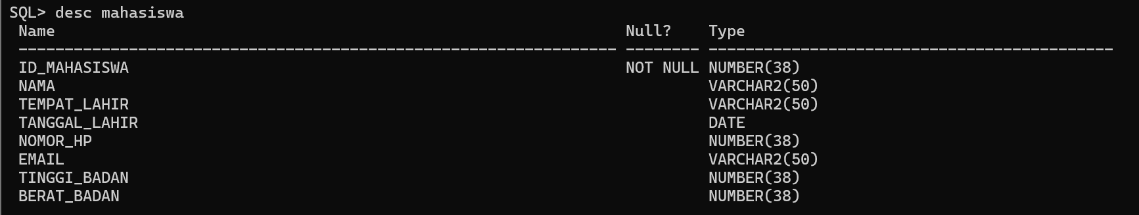

- Soal 2
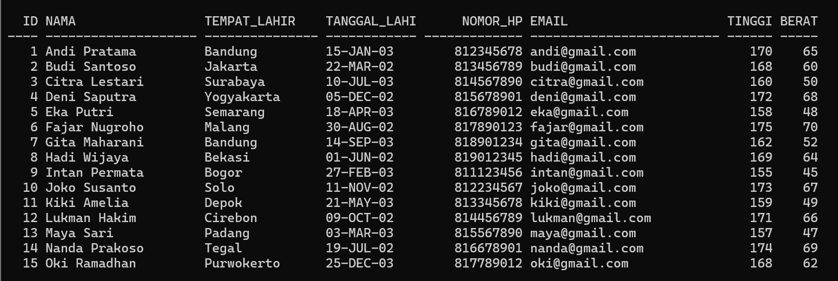
- Soal 3
  - Lower/Upper
Source Code:
SELECT LOWER(tempat_lahir) AS nama_lower FROM mahasiswa;
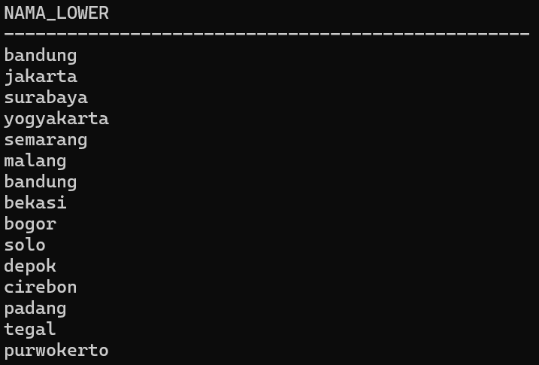

SELECT UPPER(nama) AS nama_upper FROM mahasiswa;
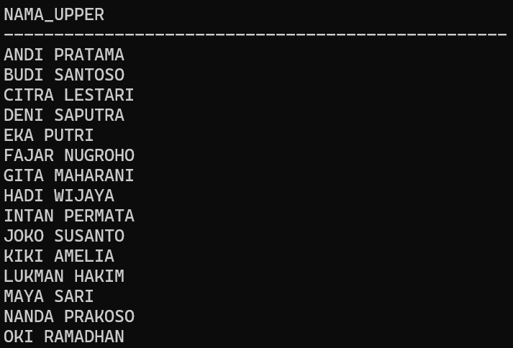
  - INITCAP
Source Code:
SELECT INITCAP(nama) AS nama_initcap FROM mahasiswa;
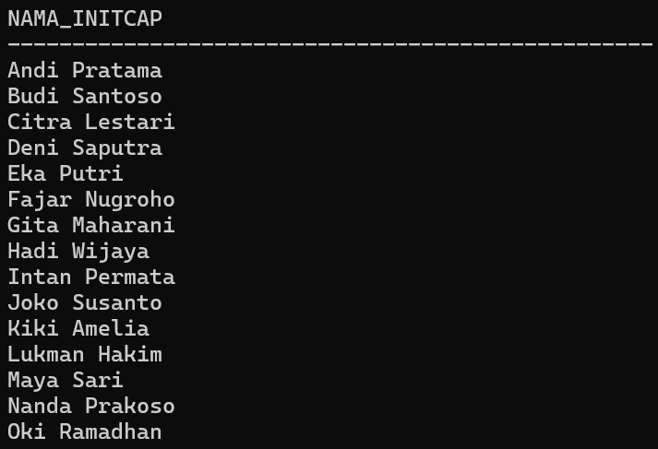
  - CONCAT
Source Code:
SELECT CONCAT(nama, ' - ') || tempat_lahir AS nama_dan_tempat FROM mahasiswa;
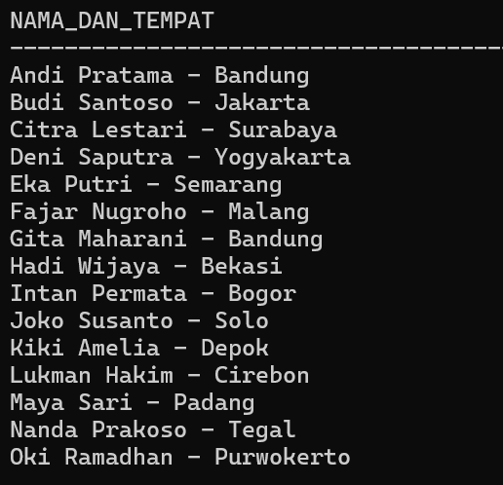
  - Length
Source Code:
SELECT tempat_lahir, LENGTH(tempat_lahir) AS panjang_tempat_lahir FROM mahasiswa;
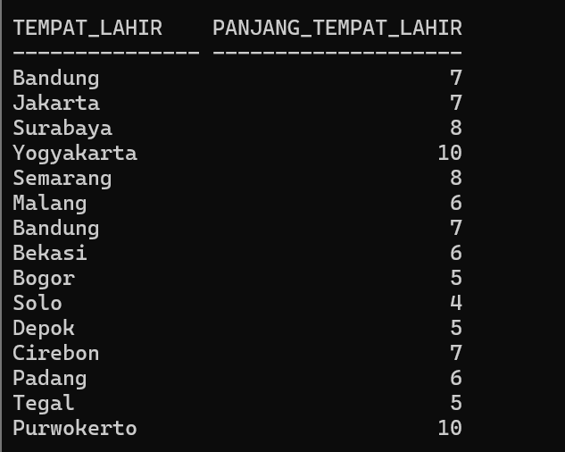
  - SUBSTR
Source Code:
SELECT nama, SUBSTR(nama,1,4) AS nama_awal FROM mahasiswa;
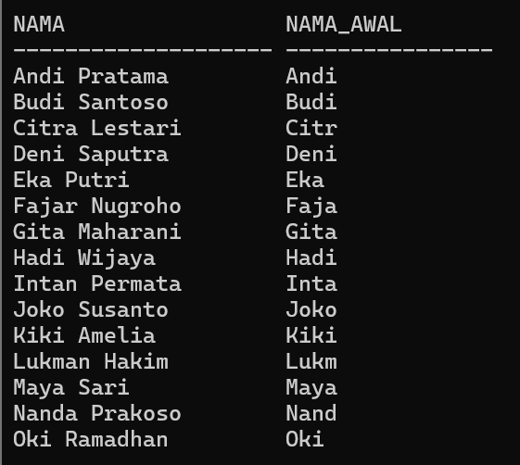

SELECT nama, SUBSTR(nama,-5) AS nama_akhir FROM mahasiswa;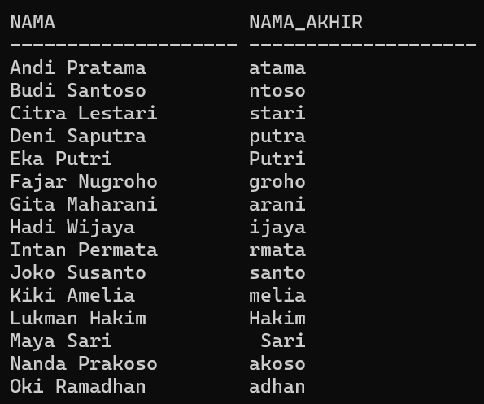
  - LPAD/RPAD
Source Code:
SELECT LPAD(tempat_lahir,15,' ') AS lpad_tempat FROM mahasiswa;
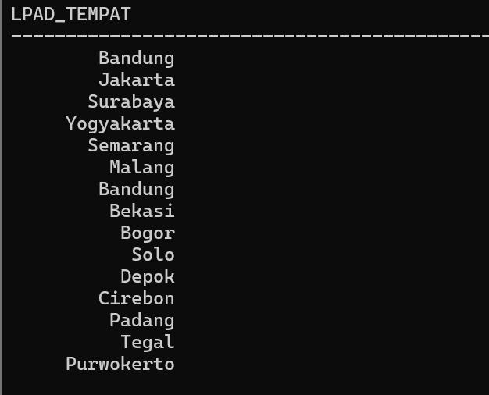

SELECT RPAD(nama,10,' ') AS rpad_nama FROM mahasiswa;
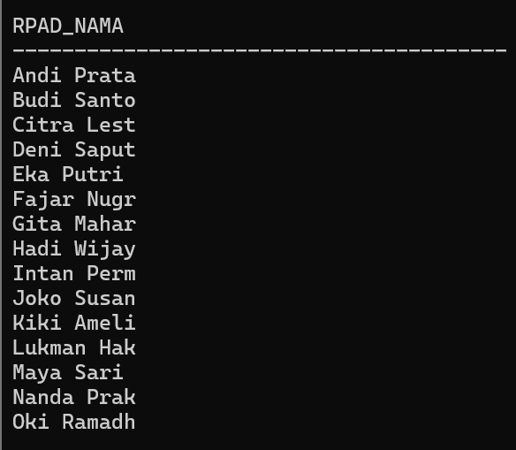

  - LTRIM/RTRIM
Source Code:
SELECT LTRIM(email, 'lukman') AS tanpa_kiri FROM mahasiswa;
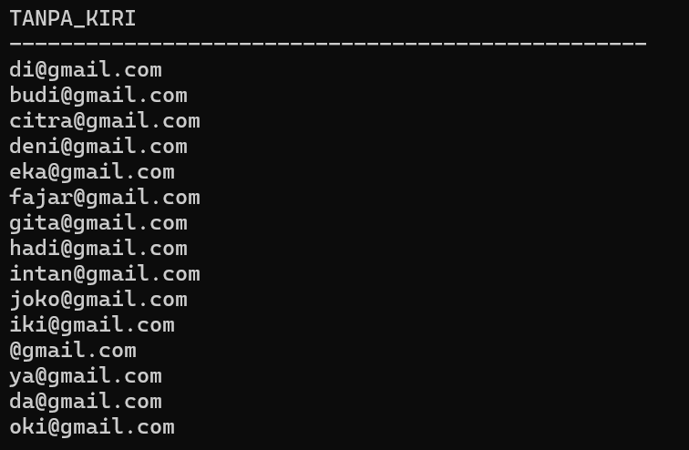

SELECT RTRIM(email, 'com') AS tanpa_kanan FROM mahasiswa;
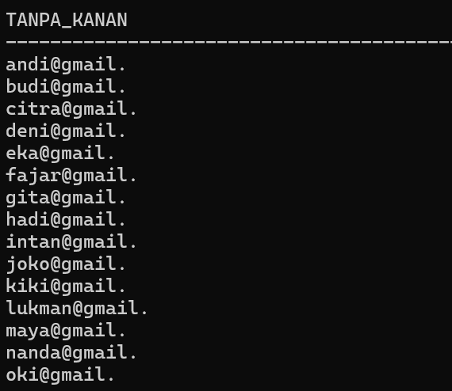
  - INSTR
Source Code:
SELECT nama, INSTR(nama,'j') AS posisi_j FROM mahasiswa;
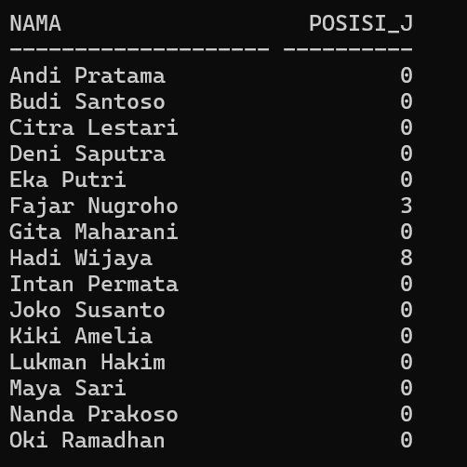
  - REPLACE
Source Code:
SELECT REPLACE(nama,'Maya','Joko') AS nama_baru FROM mahasiswa;
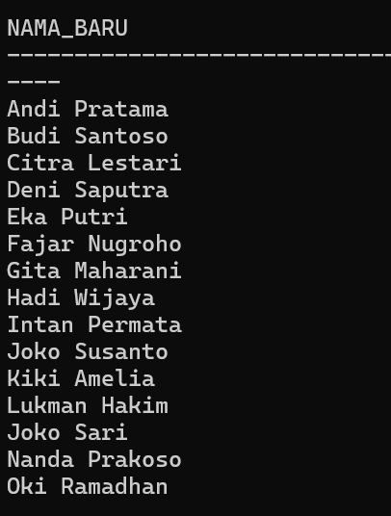
  - MM, MON, MONTH
Soource Code:
SELECT nama,
TO_CHAR(tanggal_lahir,'MM') AS bulan_angka,
TO_CHAR(tanggal_lahir,'MON') AS bulan_singkat,
TO_CHAR(tanggal_lahir,'MONTH') AS bulan_panjang
FROM mahasiswa;
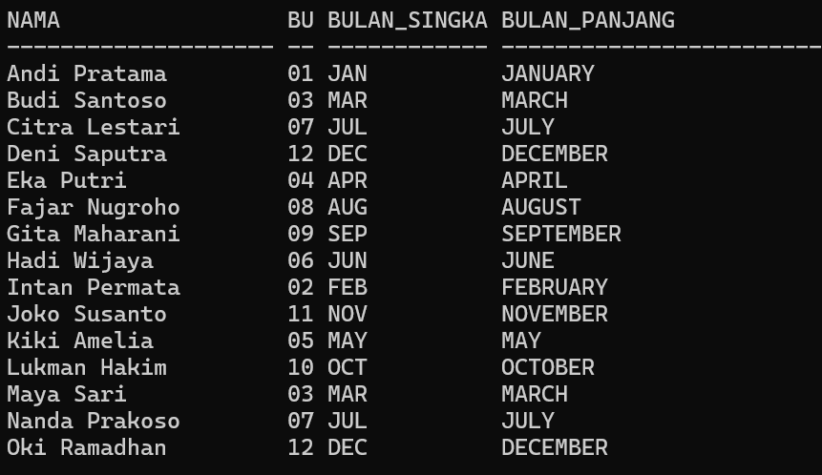
  - DD, DY
Source Code:
SELECT nama,
TO_CHAR(tanggal_lahir,'DD') AS tanggal,
TO_CHAR(tanggal_lahir,'DY') AS hari_singkat,
TO_CHAR(tanggal_lahir,'DAY') AS hari_panjang
FROM mahasiswa;

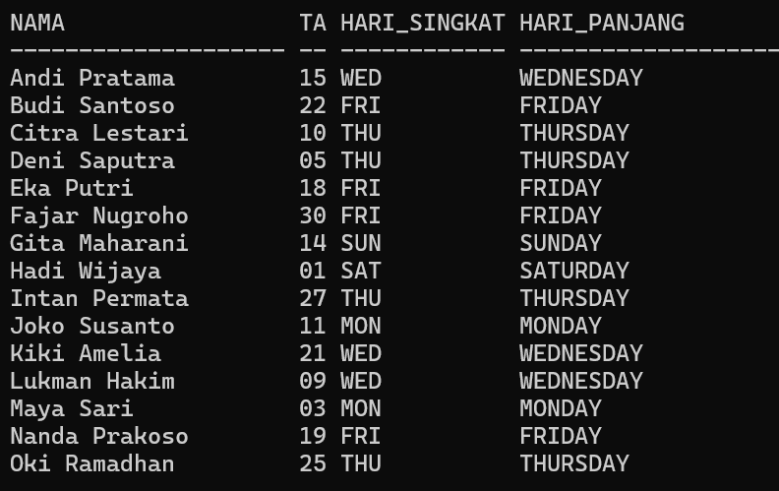

  - YYYY, YY, RR
Source Code:
SELECT nama,
TO_CHAR(tanggal_lahir,'YYYY') AS tahun_lengkap,
TO_CHAR(tanggal_lahir,'YY') AS dua_digit_tahun,
TO_CHAR(tanggal_lahir,'RR') AS tahun_rr
FROM mahasiswa;

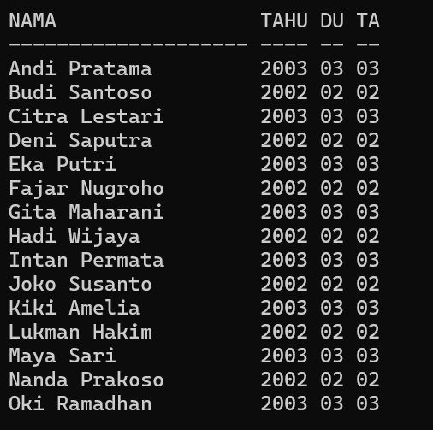
  - HH, HH24, MI, SS, AM/PM
Source Code:
SELECT tanggal_lahir AS waktu_sekarang,
TO_CHAR(tanggal_lahir,'HH:MI:SS AM') AS jam_12,
TO_CHAR(tanggal_lahir,'HH24:MI:SS AM') AS jam_24
from mahasiswa;
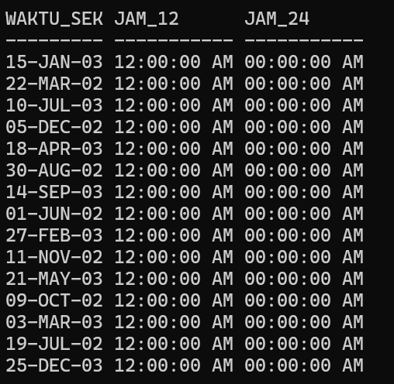
  - ADD_MONTHS(d,n)
Source Code:
SELECT nama, tanggal_lahir, ADD_MONTHS(tanggal_lahir,6) AS tambah_6_bulan
FROM mahasiswa;

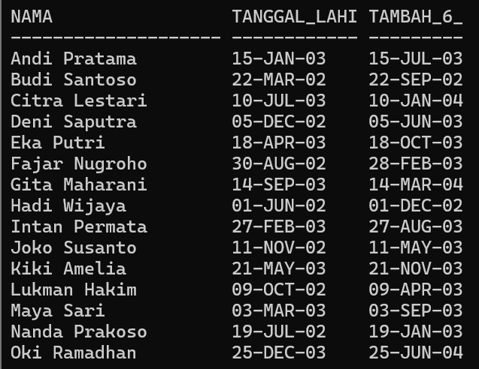

  - SYSDATE
Source Code:
SELECT nama, SYSDATE AS tanggal_sekarang FROM mahasiswa;
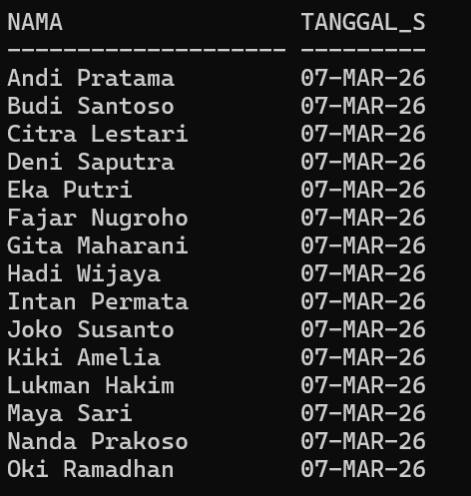
  - LAST_DAY(d)
Source Code:
SELECT nama, tanggal_lahir, LAST_DAY(tanggal_lahir) AS hari_terakhir_bulan
FROM mahasiswa;
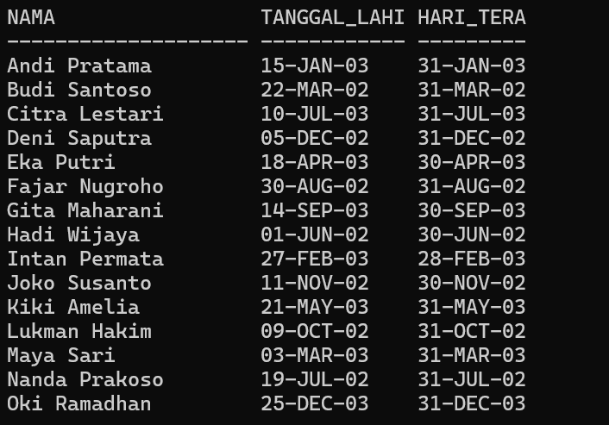
  - NEXT_DAY(d, 'DAY_NAME')
Source Code:
SELECT nama, tanggal_lahir, NEXT_DAY(tanggal_lahir,'MONDAY') AS senin_berikutnya
FROM mahasiswa;
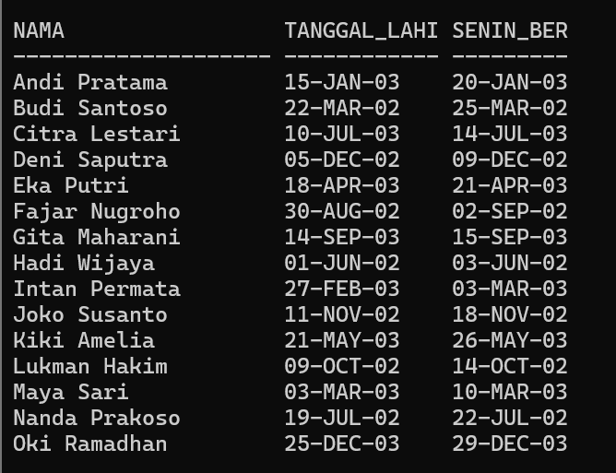
  - MONTHS_BETWEEN(d1,d2)
Source Code:
SELECT nama, tanggal_lahir, MONTHS_BETWEEN(SYSDATE, tanggal_lahir) AS selisih_bulan
FROM mahasiswa;
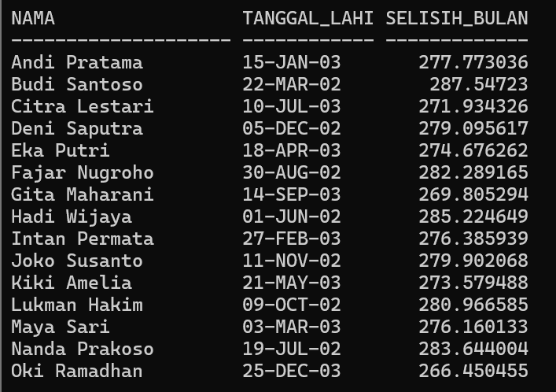
  - ROUND(d, 'MONTH'|'YEAR')
Source Code:
SELECT nama, tanggal_lahir,
ROUND(tanggal_lahir,'MONTH') AS bulat_bulan,
ROUND(tanggal_lahir,'YEAR') AS bulat_tahun
FROM mahasiswa;
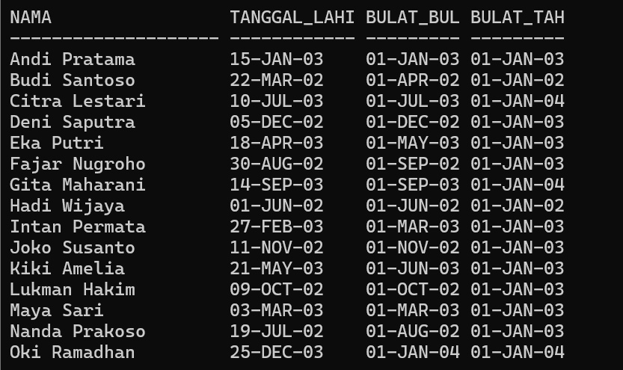
  - To_Number
Source Code:
SELECT TO_NUMBER(nomor_hp) AS nomor_hp_number FROM mahasiswa;
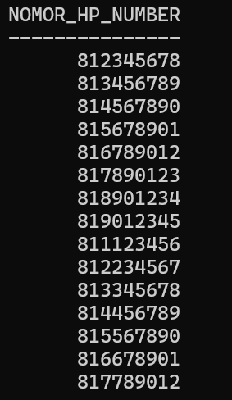
  - TO_CHAR(date)
Source Code:
SELECT
nama,
tanggal_lahir,
TO_CHAR(tanggal_lahir,'DD-MM-YYYY') AS tgl_lahir_string,
TO_CHAR(tanggal_lahir,'Day, DD Month YYYY') AS tgl_lahir_readable
FROM mahasiswa;
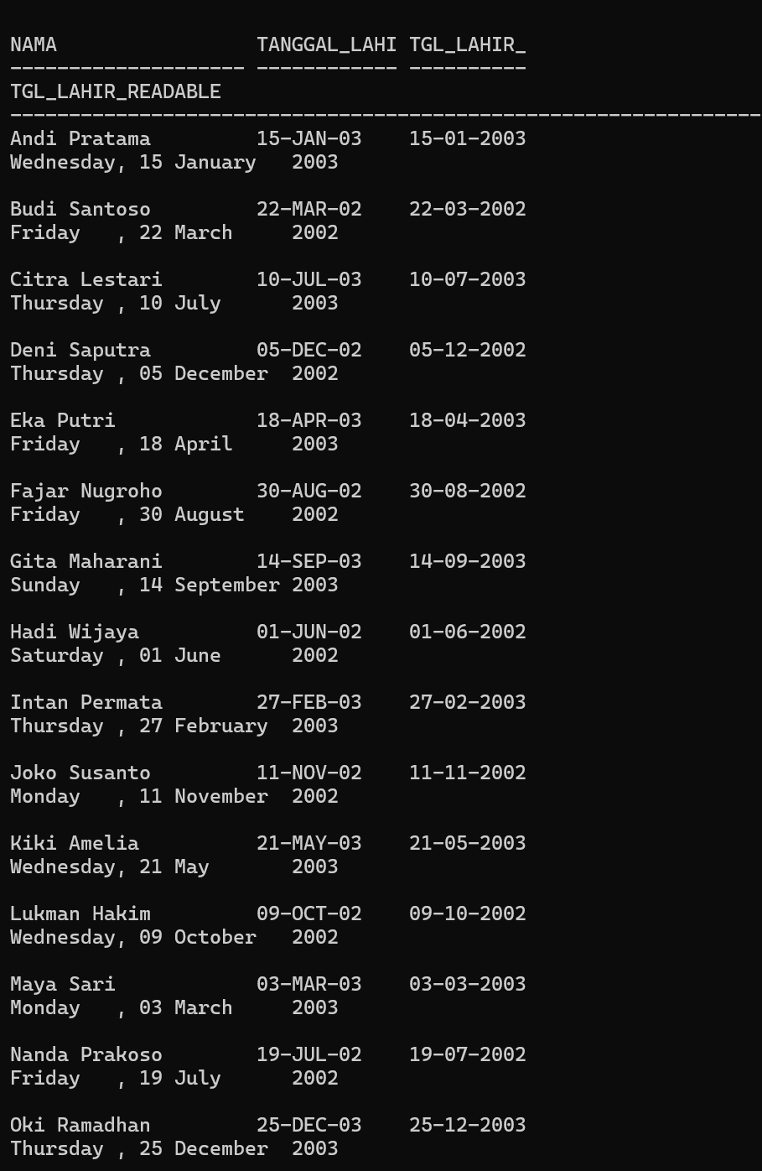
  - TO_CHAR(number)
Source Code
SELECT
nama,
tinggi_badan,
berat_badan,
TO_CHAR(tinggi_badan) AS tinggi_string,
TO_CHAR(tinggi_badan,'999') AS tinggi_string_format,
TO_CHAR(berat_badan,'999.9') AS berat_string_format
FROM mahasiswa;
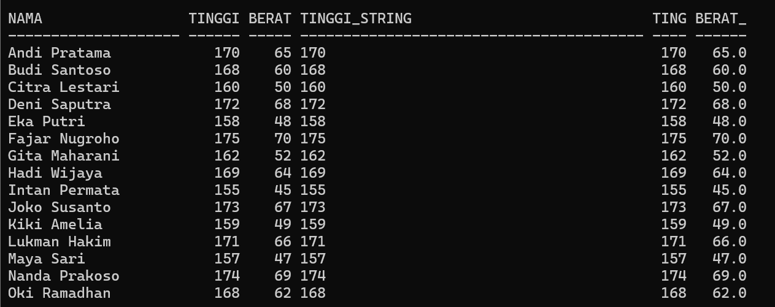
  - TO_DATE(char)
Source Code:
SELECT TO_DATE('12-05-2004','DD-MM-YYYY') AS contoh_to_date
FROM dual;
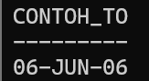
  - ABS(n)
Source Code:
SELECT
-666 AS angka_asli,
ABS(-666) AS nilai_mutlak
FROM dual;
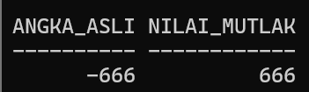
  - MOD(m,n)
Source Code:
SELECT
19 AS m,
7 AS n,
MOD(19,7) AS sisa_bagi
FROM dual;
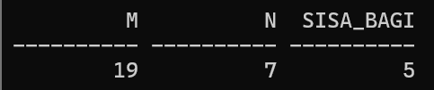
  - FLOOR(n)
Source Code:
SELECT
12.75 AS angka,
FLOOR(12.75) AS floor_angka
FROM dual;
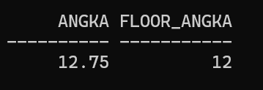
  - CEIL(n)
Source Code:
SELECT
12.25 AS angka,
CEIL(12.25) AS ceil_angka
FROM dual;
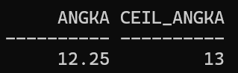
  - POWER(m,n)
SELECT
5 AS m,
3 AS n,
POWER(5,3) AS pangkat
FROM dual;
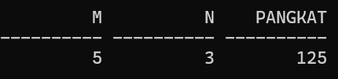
  - ROUND(n[,m])
Source Code:
SELECT
123.4567 AS angka,
ROUND(123.4567) AS bulat,
ROUND(123.4567,2) AS bulat_2_desimal
FROM dual;
